A Mini Project Report on

[ Student Result Management System ]

Submitted in partial fulfillment of the requirements for the award of the degree of
BACHELOR OF ENGINEERING / TECHNOLOGY
in
[ Electronics and Communication Engineering ]
Submitted by

[ ARYAN ]
[ 26BEC10102]
Under the guidance of

[ Priyadarshini Mam]

[ SCOPE ]
[ VIT ]
[ VIT Bhopal ]
[September,2026 ]
ABSTRACT
This project presents the design and implementation of a Student Result Management system developed using the Python programming language. The main objective of this project is to The purpose of this project is to design and develop a web-based Student Management System that allows an institution to store, retrieve, update and analyse student data efficiently and securely.
The application is built using core Python concepts including Loops, Def Functions, functions, conditions. The system allows users and authority to store, edit and view the results of students in a single program so they do not have to use the hectic method to store and view on paper as it is inconvenient in this era of modernisation.
The proposed system is simple, user-friendly, and can be executed on any computer with Python 3 installed. It demonstrates how basic programming concepts can be combined to build a meaningful application. The project can be extended in future by adding a graphical interface and allowing every student to view their result by making a login Id system.

TABLE OF CONTENTS
Chapter | Title | Page No.
 | Abstract | 4
 | Table of Contents | 5
1 | INTRODUCTION | 6
 | 1.1 Overview | 6
 | 1.2 Problem Statement | 6
 | 1.3 Objectives | 6
 | 1.4 Scope of the Project | 7
2 | SYSTEM REQUIREMENTS | 8
 | 2.1 Hardware Requirements | 8
 | 2.2 Software Requirements | 8
 | 2.3 Python Concepts Used | 8
3 | SYSTEM DESIGN | 9
 | 3.1 System Architecture | 9
 | 3.2 Flowchart | 10
4 | IMPLEMENTATION | 11
 | 4.1 Sample Code | 11
 | 4.2 Explanation of Code | 15
5 | RESULTS AND OUTPUT | 16
 | 5.1 Screenshots | 16
6 | CONCLUSION AND FUTURE SCOPE | 18
 | 6.1 Conclusion | 18
 | 6.2 Future Enhancements | 18
 | REFERENCES | 18
CHAPTER 1

INTRODUCTION

1.1 Overview
In today's digital era, computer applications have become an essential part of learning and productivity. Python, being a simple and powerful programming language, is widely used to build applications for various real-world problems.
This project titled “Student Result Management System" is a Python-based application that purpose of this project is to design and develop a web-based Student Management System that allows an institution to store, retrieve, update and analyse student data efficiently and securely.
The project has been developed as part of the first-year academic curriculum with the goal of applying fundamental Python programming concepts to build a functional, small-scale application.

1.2 Problem Statement
Authorities require a centralised system where the marks of all the students can be stored so that everyone can easily store, view ,edit the marks of students hence replacing the hectic system of maintaining all the records on paper as this is a more convenient method and this system also protects data for being erased or getting lost .

1.3 Objectives
- To design and develop a Python-based code.
- To apply core Python concepts such as loops, conditionals and os.
- To provide a simple and user-friendly console interface for the user.
- To handle user inputs and display outputs correctly and efficiently.
- To demonstrate the practical application of first-year programming concepts in solving areal-world problem.

1.4 Scope of the Project
The scope of this project is limited to a console-based Python application suitable for a single user at a time. The application focuses on demonstrating clean use of programming fundamentals and can be extended in future to include a graphical interface, database connectivity, and support for multiple users.
CHAPTER 2

SYSTEM REQUIREMENTS

2.1 Hardware Requirements
Component | Minimum Requirement
Processor | Intel Core i3 or equivalent
RAM | 4 GB
Hard Disk | 10 GB free space
Display | 14-inch monitor (1366 × 768)
Keyboard | Standard 104-key keyboard
Mouse | Optical mouse

2.2 Software Requirements
Component | Specification
Operating System | Windows 10 / 11, macOS, or Linux
Programming Language | Python 3.8 or higher
IDE / Editor | IDLE, VS Code, PyCharm, or any text editor
Libraries | Only standard library (no external packages needed)

2.3 Python Concepts Used
Concept | How it is used in this project
Variables and Data Types | For storing question data, user answers, and scores
Functions | To organize code into reusable blocks (e.g. ask_question, calculate_score)
Conditional Statements | To check the correctness of user answers (if/else)
Loops | To iterate through the list of questions (for loop)
Input / Output | To read user answers and display results using input() and print()

CHAPTER 3

SYSTEM DESIGN

3.1 System Architecture
The system follows a simple, linear architecture consisting of three main layers: the input layer that accepts user answers, the logic layer that checks correctness and calculates the score, and the output layer that displays the results on the screen.
Output
Logic layer
Input layer

Fig. 3.1: System Architecture Diagram

3.2 Flowchart
The flowchart below shows the overall flow of the application, from starting the program to displaying the final score. 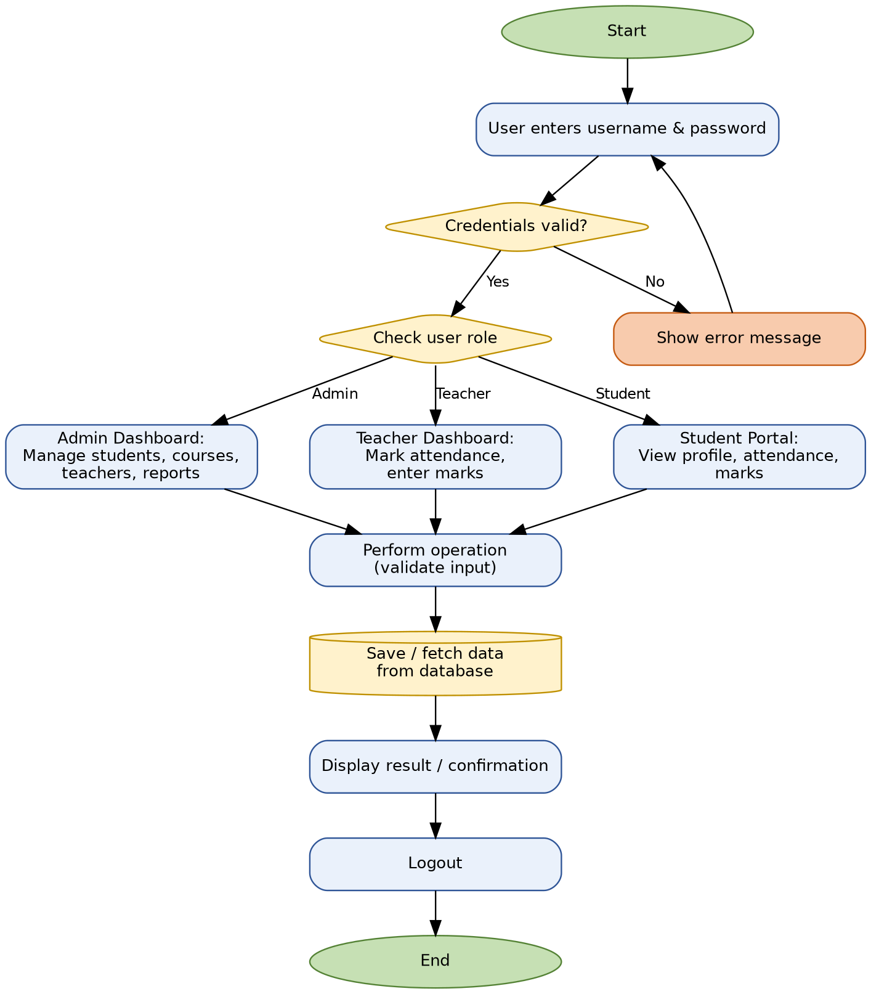
Fig. 3.2: Flowchart of the Application

CHAPTER 4

IMPLEMENTATION

4.1 Sample Code
import os
FILE_NAME = "Student_result_management_system"
SUBJECTS=["Physics","Maths","Python","Electronics","English"]
def get_grade(percentage):
if percentage >= 90:
return "A+"
elif percentage >= 80:
return "A"
elif percentage >= 70:
return "B"
elif percentage >= 60:
return "C"
elif percentage >= 50:
return "D"
else:
return "F"
def get_result(marks):
#40 marks to pass
for m in marks:
if m<40:
return"FAIL"
return "PASS"
def make_student(name, roll_no, marks):
total=sum(marks)
percentage= total / (len(SUBJECTS) * 100) * 100
student={
"name": name,
"roll_no": roll_no,
"marks": marks,
"total": total,
"percentage": percentage,
"grade": get_grade(percentage),
"result": get_result(marks),
}
return student
def ask_marks(subject):
while True:
text=input("Marks in " + subject + ": ").strip()
if not text.isdigit():
print("please enter a whole number")
elif int(text) > 100:
print("marks must be between 0 and 100")
else:
return int(text)
def find_student(students, roll_no):
for s in students:
if s["roll_no"] == roll_no:
return s
return None
def show_student(s):
print("\n--------------------------------")
print("Name :", s["name"])
print("Roll no :", s["roll_no"])
for i in range (len(SUBJECTS)):
print(f"{SUBJECTS[i]:<12}: {s['marks'][i]}")
print("Total :", s["total"], "/ 500")
print(f"percentage: {s['percentage']:.2f}%")
print("Grade :", s["grade"])
print("Result :", s["result"])
print("--------------------------------")
def add_student(students):
name = input("Enter name:").strip()
while name == "":
name = input("name can't be empty. Enter name: ").strip()
roll_no = input("Enter roll number: ").strip()
while roll_no== "" or find_student(students, roll_no) is not None:
print("roll number can't be empty.")
roll_no = input("Enter roll number: ").strip()
marks=[]
for subject in SUBJECTS:
marks.append(ask_marks(subject))
student = make_student(name, roll_no, marks)
students.append(student)
print("student added!")
show_student(student)
def view_students(students):
if len(students) == 0:
print("no records yet.")
return
print(f"\n{'roll_no':<10}{'Name':<20}{'Percent':<10}{'Grade':<8}{'Result'}")
print("-" * 55)
for s in students:
pct = f"{s['percentage']:.2f}%"
print(f"{s['roll_no']:<10}{s['name']:<20}{pct:<10}{s['grade']:<8}{s['result']}")
def search_student(students):
roll_no = input("enter roll number to search: ").strip()
s = find_student(students, roll_no)
if s is None:
print("student not found.")
else:
show_student(s)
def update_student(students):
roll_no = input("enter roll number to update: ").strip()
s = find_student(students, roll_no)
if s is None:
print("student not found.")
return
print("updating marks for", s["name"])
new_marks=[]
for subject in SUBJECTS:
new_marks.append(ask_marks(subject))
position = students.index(s)
students[position] = make_student(s["name"], s["roll_no"], new_marks)
print("Updated!")
show_student(students[position])
def delete_student(students):
roll_no = input("enter roll number to delete;").strip()
s = find_student(students, roll_no)
if s is None:
print("student not found")
else:
students.remove(s)
print("student deleted")
def save_students(students):
file = open(FILE_NAME, "w")
for s in students:
marks_text = ",".join(str(m) for m in s["marks"])
file.write(s["roll_no"] + "," + s["name"] + "," + marks_text + "\n")
file.close()
print("records saved.")
def load_students():
students=[]
if not os.path.exists(FILE_NAME):
print("No saved records found")
return students
file = open(FILE_NAME, "r")
for line in file:
parts = line.strip().split(",")
if len(parts) == 2 + len(SUBJECTS):
marks = []
for m in parts [2:]:
marks.append(int(m))
students.append(make_student(parts[1], parts[0], marks))
file.close()
print("Loaded", len(students), "records(s).")
return students
def main():
students = load_students()
while True:
print("\n===== STUDENTS RESULT SYSTEM =====")
print("1. Add Student")
print("2. View all Students")
print("3. Search Student")
print("4. Update marks")
print("5. Delete Students")
print("6. Save Students")
print("7. save and exit")
choice = input("Enter Choice(1-7):").strip()
if choice == "1":
add_student(students)
elif choice == "2":
view_students(students)
elif choice == "3":
search_student(students)
elif choice == "4":
update_student(students)
elif choice == "5":
delete_student(students)
elif choice == "6":
save_students(students)
elif choice == "7":
save_students(students)
print("Thank You For using Student result management system")
break
else:
print("Invalid Choice")
main()

4.2 Explanation of Code
This is the code to store, view and edit the marks and result of students using conditions and loops and many conditionals to give an user friendly interface to store the marks of every student.
CHAPTER 5

RESULTS AND OUTPUT

5.1 Screenshots
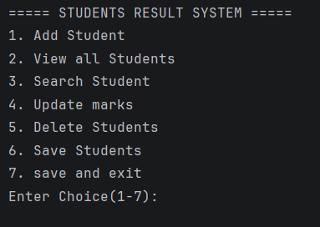Fig. 5.1: Welcome screen of the quiz application

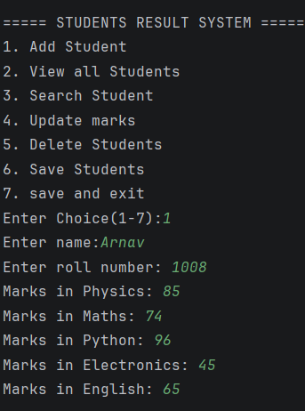

Sample text output when the program runs
========================================
WELCOME TO THE PYTHON QUIZ
========================================
Q1. Which keyword is used to define a function in Python?
- func
- def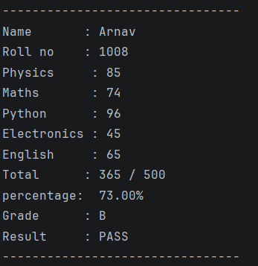
- function
- define
Your answer (A/B/C/D): B >> Correct!
Q2. What is the output of print(2 ** 3)?
- 6
- 5
- 8
- 9
Your answer (A/B/C/D): C >> Correct!
========================================
You scored 3 out of 3 (100.0%)
========================================

CHAPTER 6

CONCLUSION AND FUTURE SCOPE

6.1 Conclusion
This project titled "Student Result Management system" was successfully designed and implemented using the Python programming language. The application meets the objectives set out at the beginning: it accepts user input, processes it correctly using conditional and looping structures, and produces the expected output.
The project helped in understanding and applying fundamental Python concepts including data types, functions, control flow, and data structures such as lists and dictionaries. Testing confirmed that the application behaves correctly for both valid and invalid user inputs.
Overall, the project achieved its purpose of demonstrating how first-year programming skills can be combined to build a small but complete and usable application.

6.2 Future Enhancements
■ Student Tip: Write 3–5 ideas for extending your project. Do not overpromise — pick realistic ideas that build on what you already have.
- Add a Graphical User Interface (GUI) using the Tkinter library for a more attractive anduser-friendly experience.
- Allow multiple users to log in with a username and maintain the result data .
- Deploy the application as a web app using Flask or Streamlit so it can be accessed from a browser.
- Anybody as per their respective roles can see the results and faculties can edit the marks and result.

REFERENCES.
- Reema Thareja, Python Programming Using Problem Solving Approach, Oxford University Press, 2017.
- Mark Lutz, Learning Python, 5th Edition, O'Reilly Media, 2013.
- Zed A. Shaw, Learn Python 3 the Hard Way, Addison-Wesley, 2017.
- Python Software Foundation, Python 3 Official Documentation, available at: https://docs.python.org/3/
- GeeksforGeeks, Python Tutorials, available at: https://www.geeksforgeeks.org/python-programming-language/
- W3Schools, Python Tutorial, available at: https://www.w3schools.com/python/

